Practical Lab Report — Network Security Essentials
Prepared by: Omkar Sawant
Platform: TryHackMe — Network Security Essentials
Date completed: 25 May 2026
Project: Implementing a Secure Network Architecture for a Large Enterprise
Organisation: Spinnaker Analytics

Room completed: 8 tasks · 96 points · User: sawant052

1. Overview
- This report documents the completion of the TryHackMe room 'Network Security Essentials' as the practical component of Perimeter Security of the Spinnaker Analytics project.
- The lab involved analysing real perimeter security logs, firewall logs, VPN authentication logs, WAF logs, IDS/IPS alerts and correlating findings using Splunk SIEM.0.
- .
- The lab directly validates the perimeter security controls documented in the Perimeter Security Configuration Guide, providing hands-on evidence of how NGFW, WAF, VPN gateway, and IDPS generate logs and how those logs are analysed to detect attacks.

2. Lab Environment
- Platform: TryHackMe browser-based Linux VM (Ubuntu)
- Tools used: Pluma text editor, bash terminal, Splunk 10.0.0 (local instance)
- Log files analysed: firewall_logs.txt, vpn_logs.txt, waf_logs.txt, ids_alerts.log, ids_alerts.json
- SIEM: Splunk with network_logs index ingesting all log sources

3. WAF Log Analysis — Attack Detection

3.1 SQL Injection Detection
- The WAF log was analysed to identify blocked attack attempts.
- Line 10 of waf_logs.txt showed a BLOCK action against a SQL injection attempt from IP 198.51.100.12, targeting /products.php with a UNION SELECT payload.
- The WAF rule_id 942100 triggered the block.

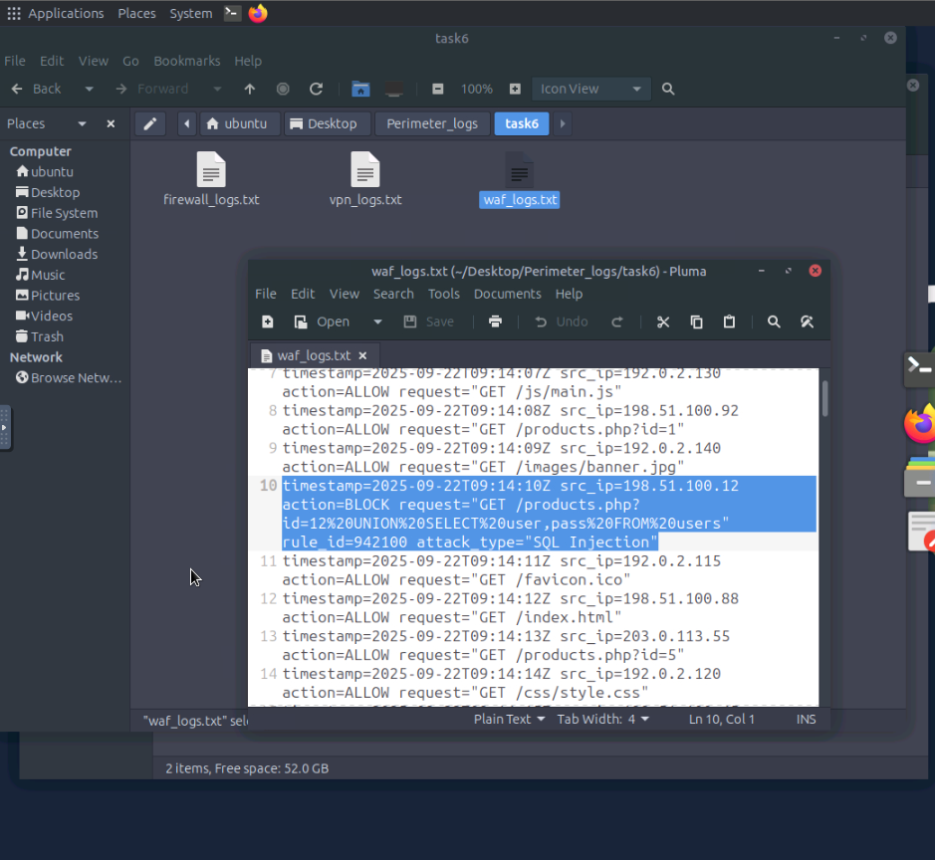
Figure 1: WAF log — SQL injection blocked (rule_id 942100, src: 198.51.100.12)

3.2 XSS Detection
- Further analysis of waf_logs.txt identified a cross-site scripting (XSS) attempt at line 46.
- The attacker at 198.51.100.12 attempted to inject a script tag via /search.php.
- The WAF rule_id 941100 blocked the request.

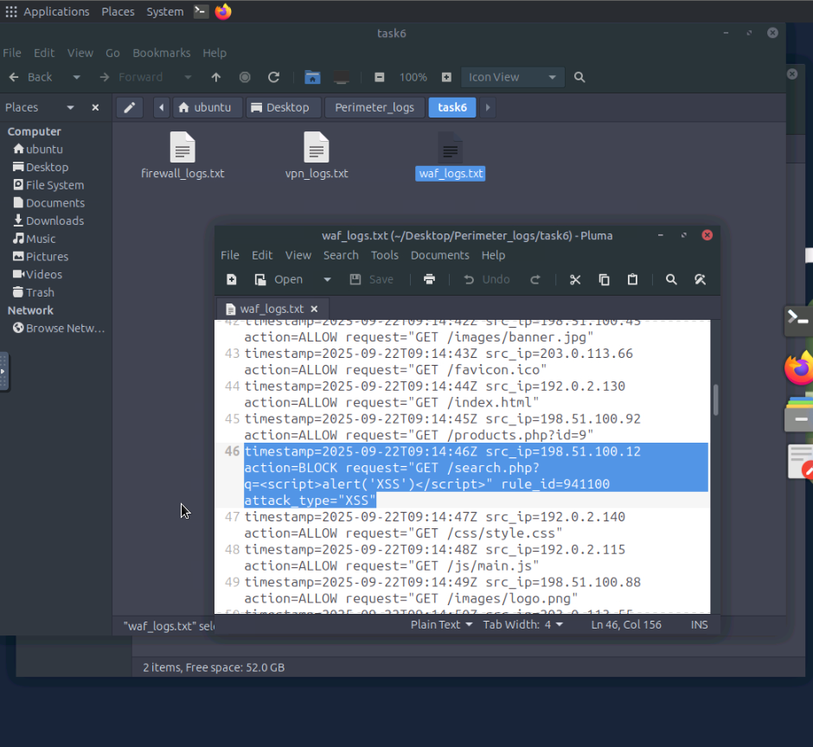
Figure 2: WAF log — XSS attack blocked (rule_id 941100, src: 198.51.100.12)

3.3 Directory Traversal Detection
- A directory traversal attack was identified at line 102 of waf_logs.txt.
- The attacker attempted to access /../../../../etc/passwd via a GET request.
- WAF rule_id 930120 blocked the request, preventing access to the system password file.

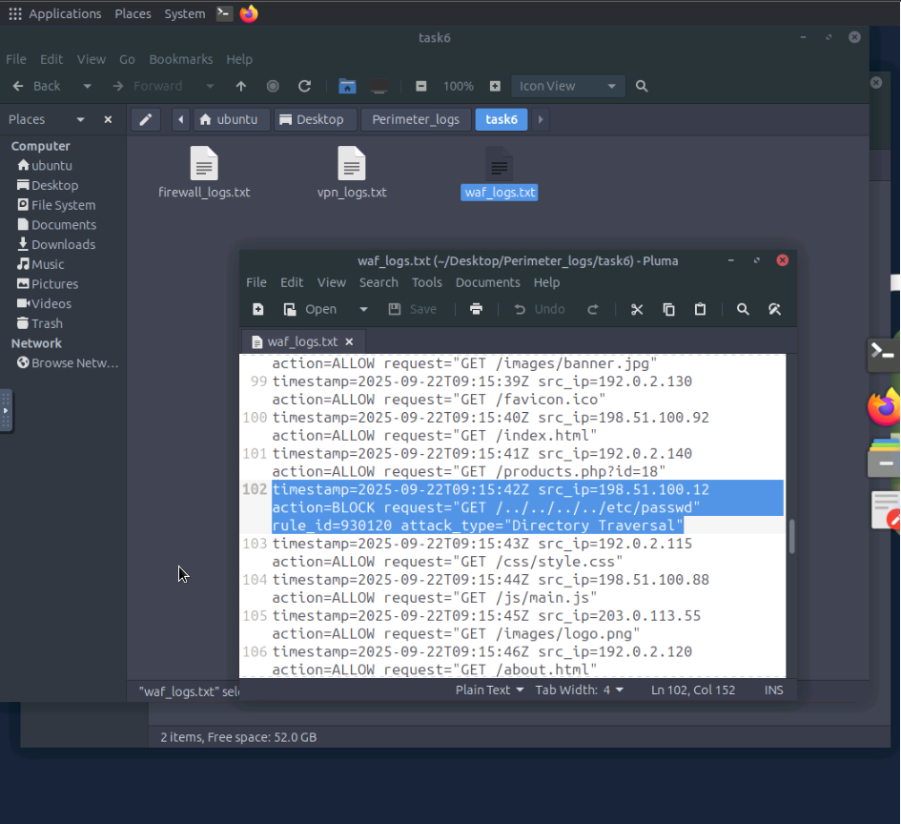
Figure 3: WAF log — Directory traversal blocked (rule_id 930120, src: 198.51.100.12)

3.4 Additional WAF Findings
- Screenshots 4 show further WAF log entries, confirming continued attack attempts from 198.51.100.12 across multiple attack vectors throughout the session window.

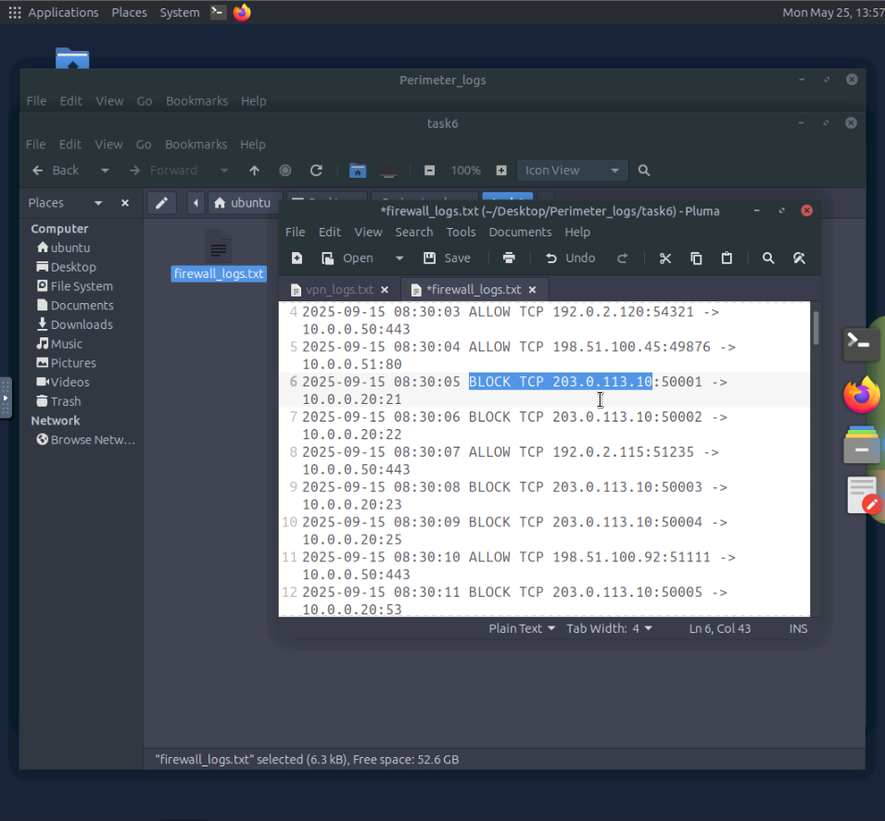
Figure 4: WAF log — continued attack traffic from 198.51.100.12

4. VPN Log Analysis — Brute-Force Detection

4.1 Credential Stuffing / Brute-Force Attack
- Analysis of vpn_logs.txt revealed a sustained credential stuffing attack originating from IP 45.137.22.13.
- The attacker attempted authentication with a long list of common usernames : root, test, guest, support, backup, user, ftpuser, webmaster, sales, info, demo, login, student, manager, hr, it, marketing, finance, billing, john, jane, susan, and many others ;
- All resulting in FAILED_AUTH responses.

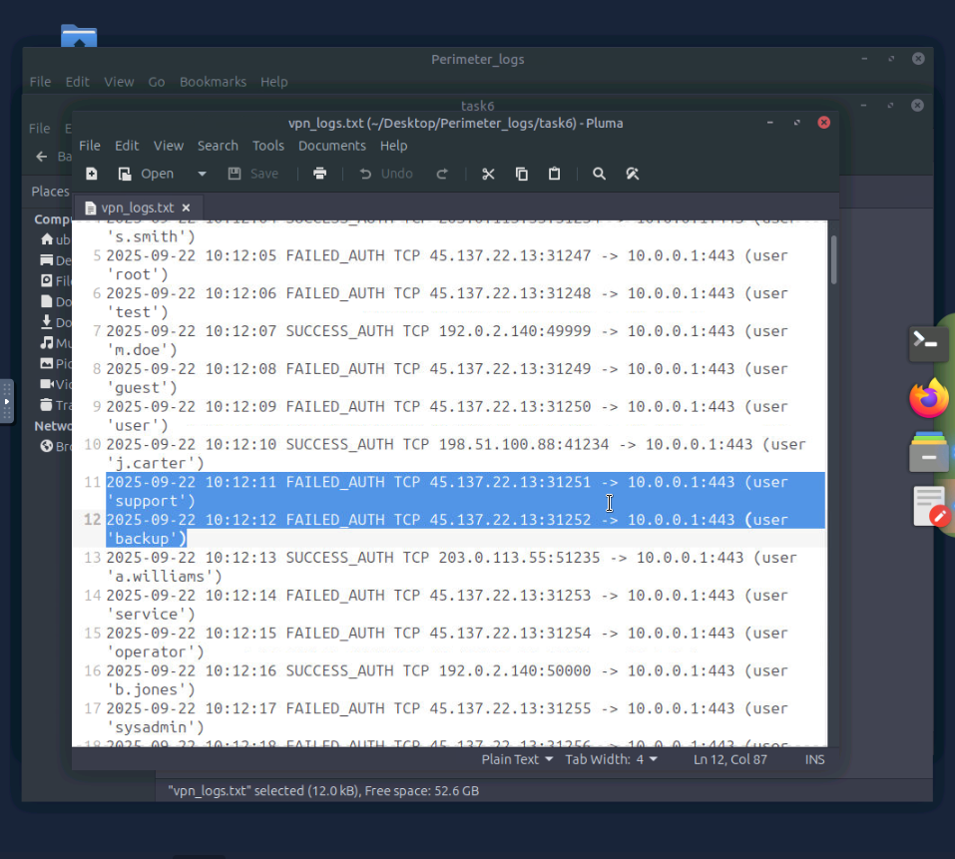
Figure 5: VPN log — brute-force authentication attempts from 45.137.22.13

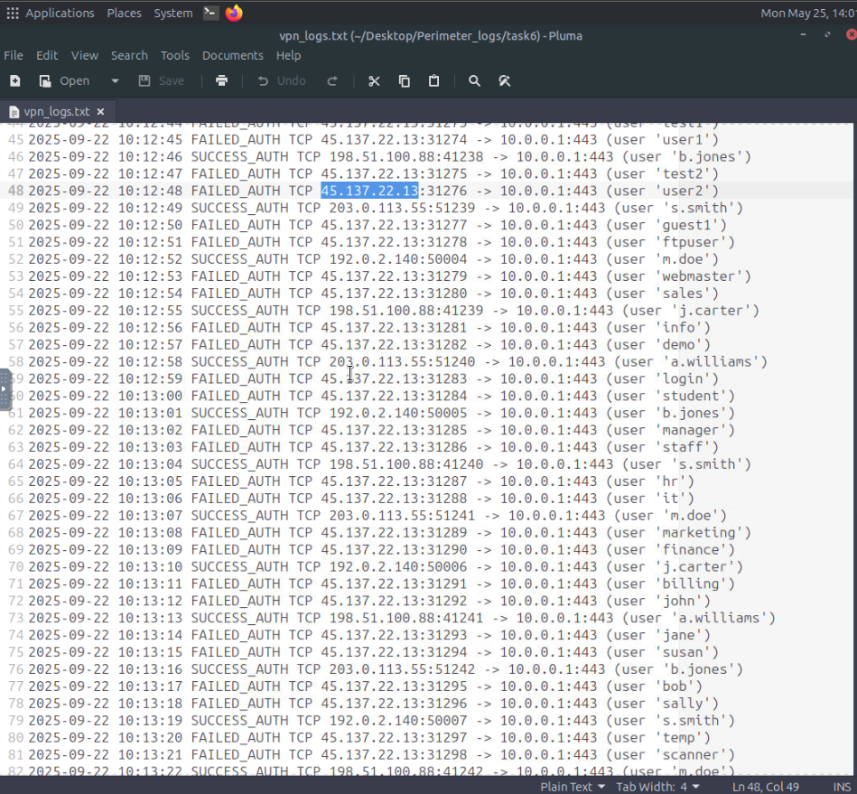
Figure 6: VPN log — continued credential stuffing, legitimate users authenticating from trusted IPs

4.2 Legitimate vs Malicious Authentication
- Legitimate successful authentications originated from trusted IP ranges (192.0.2.x, 198.51.100.88, 203.0.113.55) for users s.smith, m.doe, j.carter, a.williams, and b.jones.
- All failed authentications came exclusively from 45.137.22.13, making it straightforward to identify and block the attacking IP.

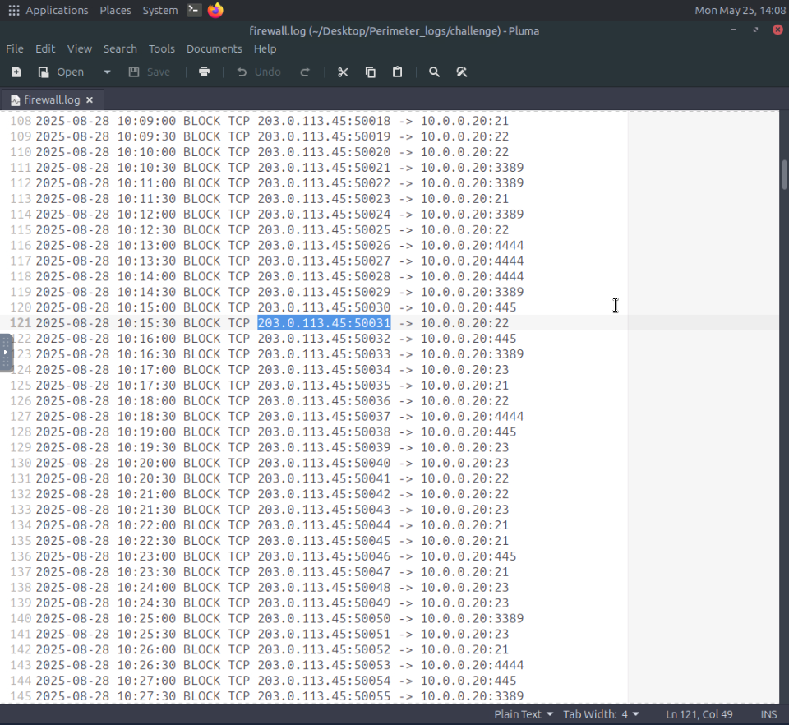
Figure 7: VPN log — pattern distinguishing legitimate users from brute-force attacker

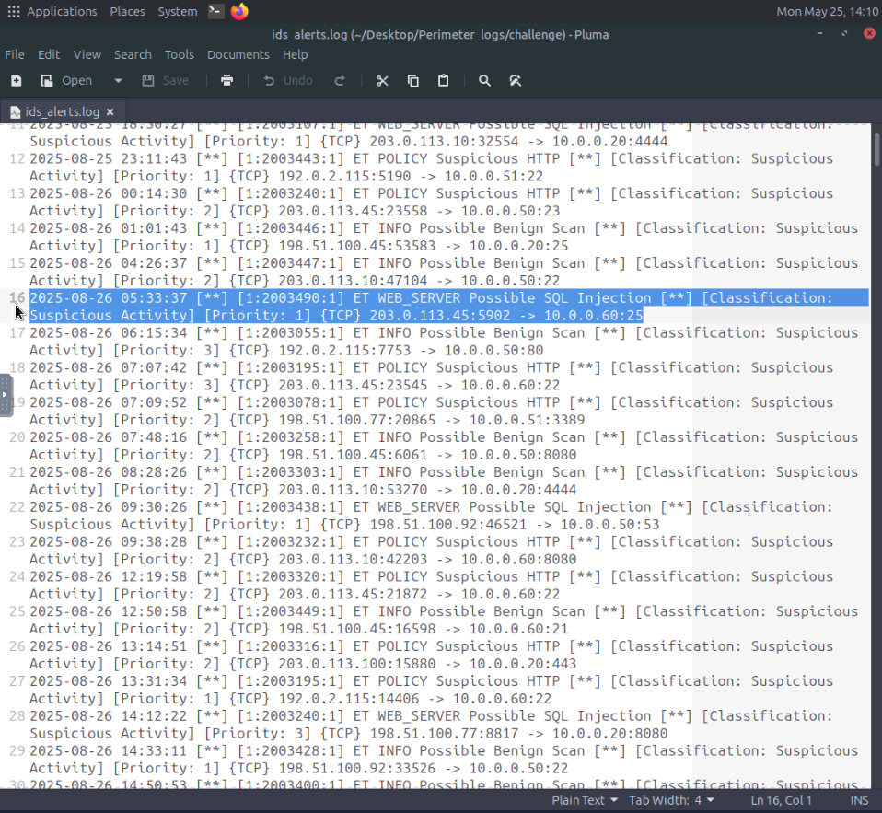
Figure 8: VPN log — additional failed auth attempts showing username enumeration

5. Firewall and IDS Log Analysis

5.1 Firewall Log — Terminal Analysis
- The challenge directory was explored using the terminal to analyse firewall.log and ids_alerts.log.
- The head command was used to preview both log files.
- The firewall log showed standard ALLOW traffic patterns.
- While the IDS alert log contained Suricata-format alerts including ET POLICY Suspicious HTTP, ET INFO Possible Benign Scan, ET WEB_SERVER Possible SQL Injection, and ET POLICY Suspicious HTTP classifications.

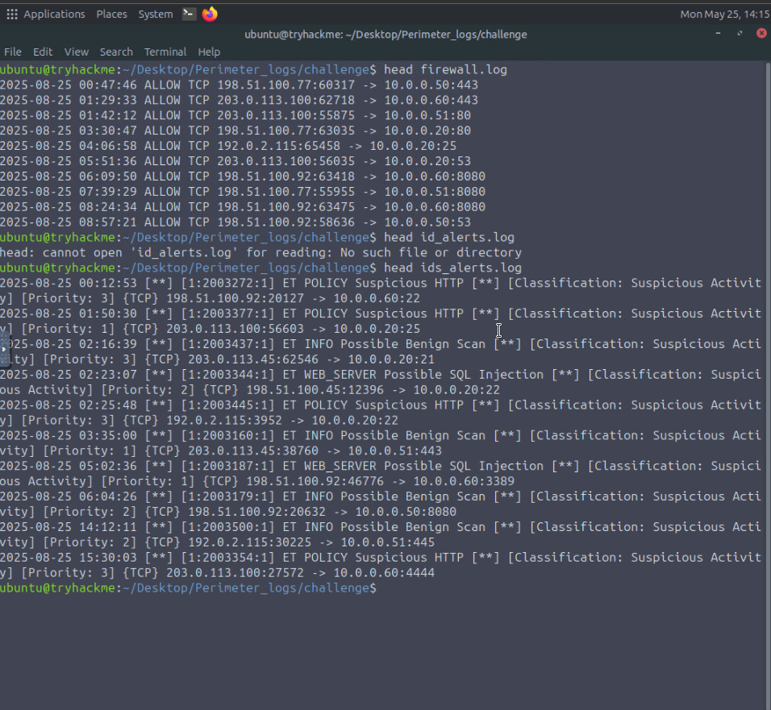
Figure 10: Terminal — head firewall.log and head ids_alerts.log showing IDS alert format

5.2 Firewall Log — Suspicious IP Investigation
- The firewall log was filtered to identify traffic patterns from specific IP addresses.
- Analysis of traffic from 203.0.113.100 revealed consistent ALLOW entries to internal hosts on ports 443, 80, 3389, and 8080
- This is indicating a potential internal reconnaissance or lateral movement pattern across multiple services.

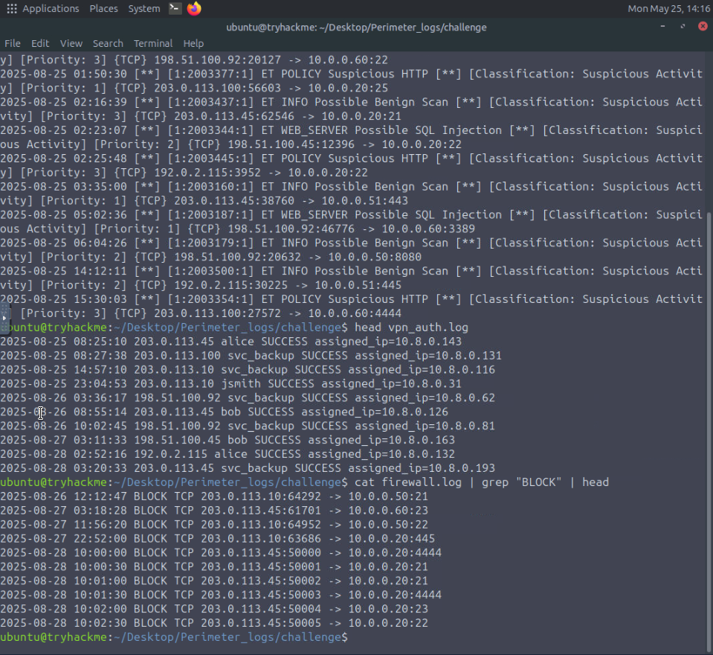
Figure 11: Firewall log — filtered traffic from 203.0.113.100 across multiple destination ports

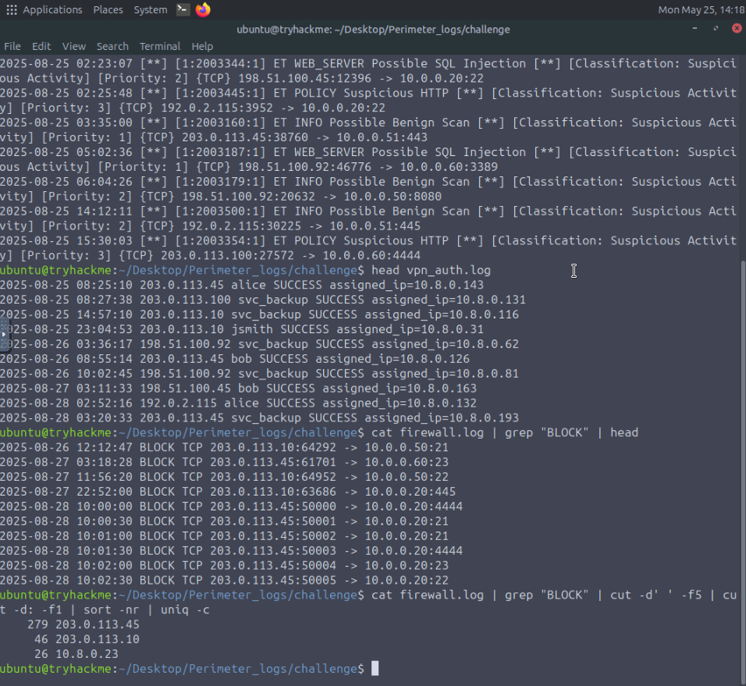
Figure 12: Firewall log — continued traffic analysis showing destination port variety

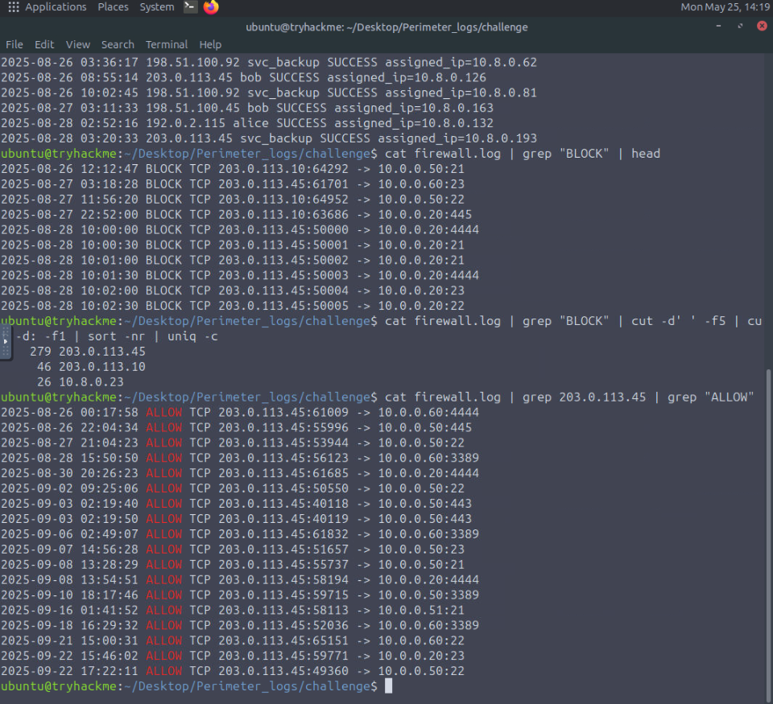
Figure 13: Firewall log — traffic correlation across source IPs

5.3 Firewall Log — ALLOW Traffic from Specific Host
- The grep command was used to filter ALLOW traffic from IP 10.8.0.23 to identify its communication patterns.
- The output showed high-frequency traffic across hourly intervals to multiple internal hosts on ports 22, 445, 3389, and 8080.
- This is consistent with an automated scanning tool performing internal network reconnaissance.

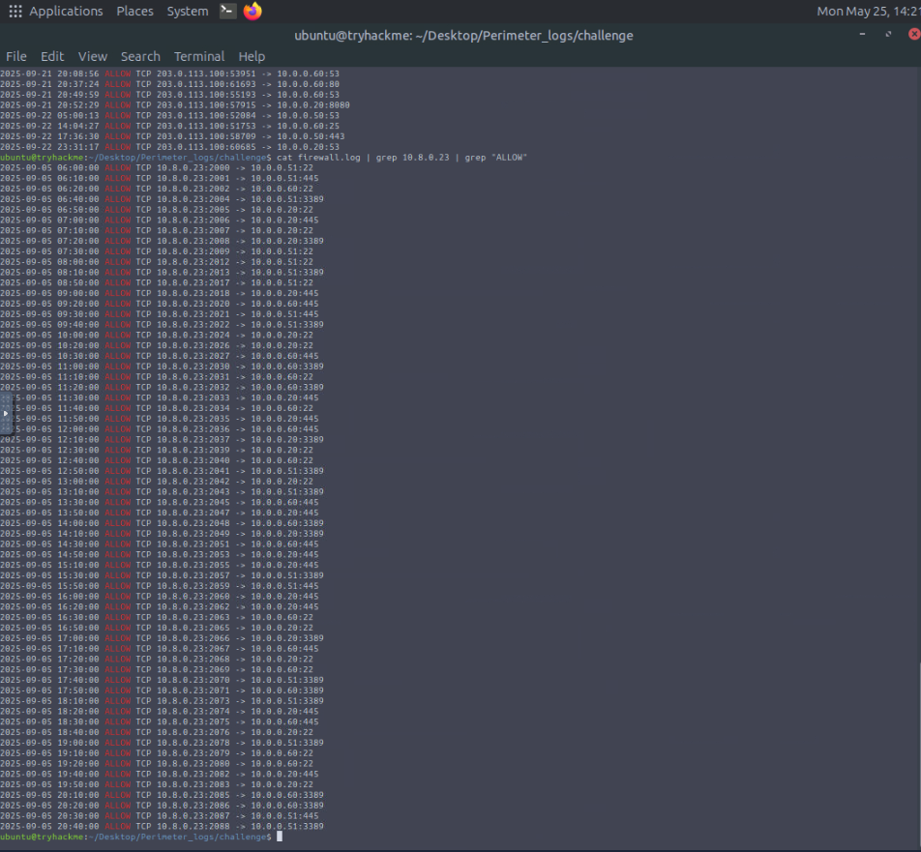
Figure 15: Firewall log — high-frequency ALLOW traffic from 10.8.0.23 indicating internal scan

5.4 IDS Alerts — C2 Beaconing Detection
- IDS alert analysis identified ET TROJAN Possible C2 Beaconing alerts originating from internal host 10.0.0.60 communicating to external IP 198.51.100.7 on port 4444
- This is a common C2 callback port.
- The beaconing occurred at regular 6-hour intervals (01:00, 07:00, 13:00, 19:00), a strong indicator of malware command-and-control activity.

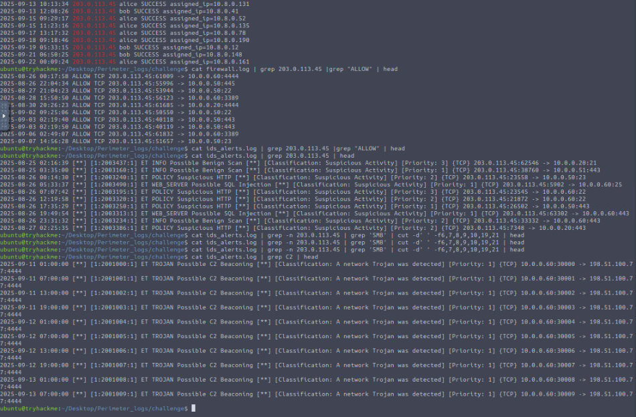
Figure 20: IDS alert — ET TROJAN C2 beaconing from 10.0.0.60 to 198.51.100.7:4444 at 6-hour intervals

5.5 Short-Answer Investigation Findings
- The following screenshots show terminal commands used to answer specific investigation questions in the lab, including filtering by IP, grep-based log parsing, and cross-referencing firewall with IDS logs:

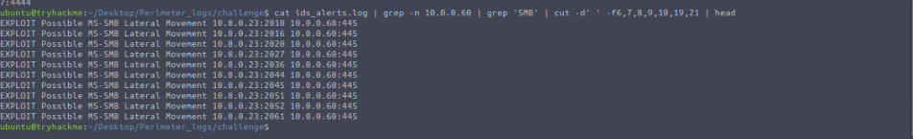
Figure 21: Terminal command — grep filter result

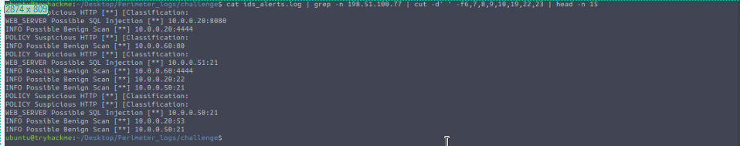
Figure 22: Terminal command — cross-reference firewall and IDS logs

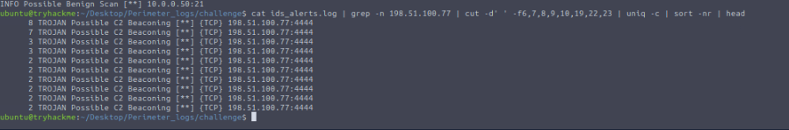
Figure 23: Terminal — answer verification

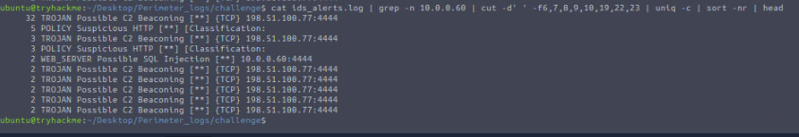
Figure 24: Terminal — additional log query result

6. Splunk SIEM Analysis

6.1 Ingesting Logs into Splunk
- All perimeter log sources were ingested into Splunk under the network_logs index.
- The Splunk search interface was used to query across firewall_logs.json and ids_alerts.json simultaneously.
- This enabled cross-source correlation that would not be possible analysing individual log files.

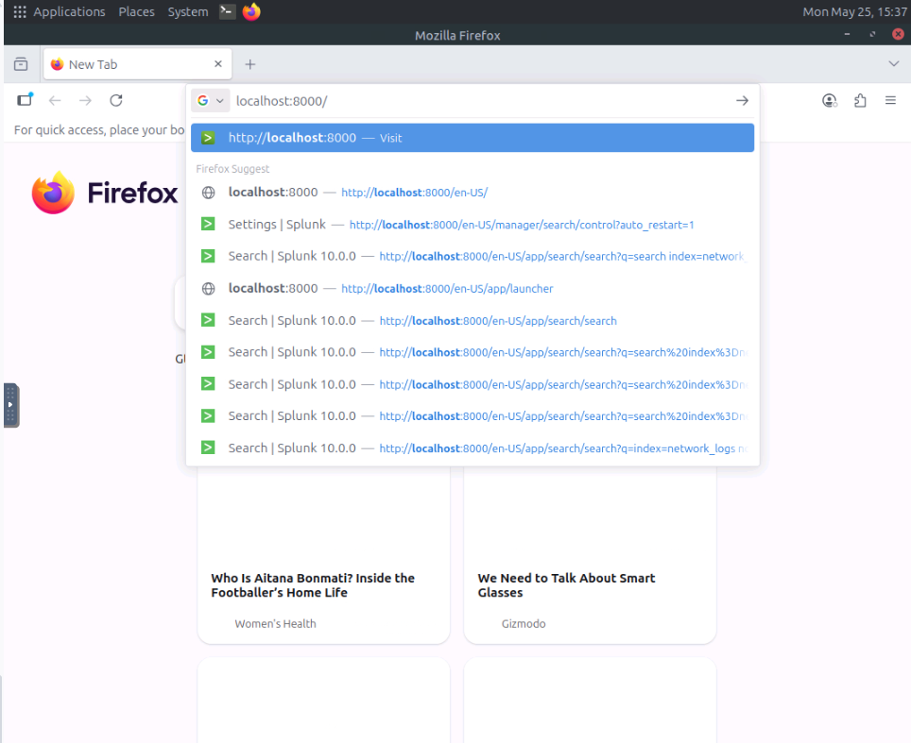
Figure 32: Splunk — search interface with network_logs index, firewall and IDS sources visible

6.2 IDS Alert Distribution
- A Splunk field analysis on the alert field revealed the top 10 alert types across the entire log dataset. The distribution showed:
- ET INFO Possible Benign Scan
  - 181 events (18.4%)
  - highest volume, indicating active scanning
- ET WEB_SERVER Possible SQL Injection
  - 167 events (17.0%)
  - sustained web application attacks
- ET POLICY Suspicious HTTP
  - 165 events (16.8%)
  - policy violations in HTTP traffic
- ET POLICY VPN Authentication Failure
  - 120 events (12.2%)
  - the brute-force VPN attack
- ET SCAN Possible Portscan
  - 120 events (12.2%)
  - network reconnaissance activity
- ET TROJAN Possible C2 Beaconing
  - 80 events (8.1%)
  - malware C2 communication
- ET INFO Possible HTTP POST Large Upload
  - 60 events (6.1%)
  - potential data exfiltration
- ET EXPLOIT Possible MS-SMB Lateral Movement
  - 32 events (3.3%)
  - lateral movement attempts

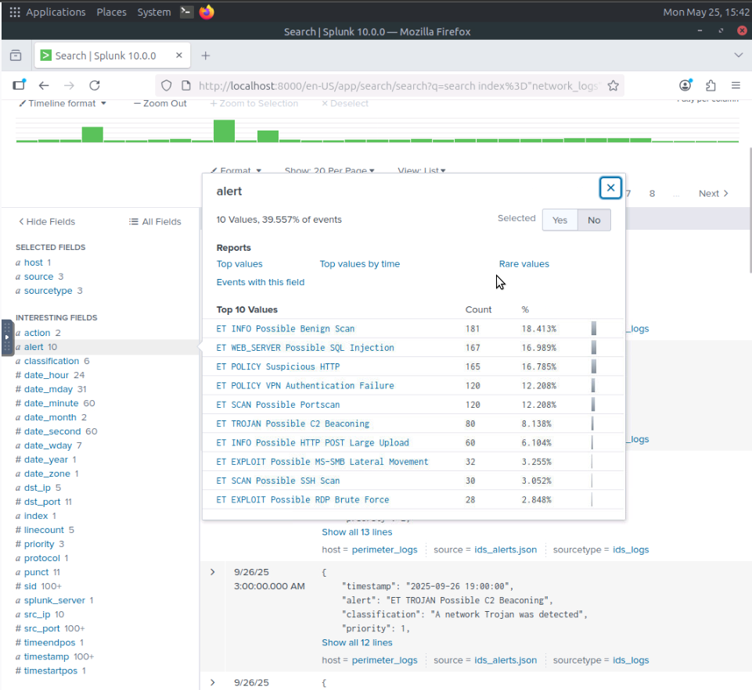
Figure 42: Splunk — Top 10 IDS alert types showing full attack landscape across all log sources

6.3 Firewall Log Event Structure in Splunk
- Expanding individual firewall log events in Splunk revealed the full field structure available for analysis: action, bytes, dst_ip, dst_port, protocol, src_ip, src_port, and timestamp.
- This field structure enables precise filtering and correlation across events.

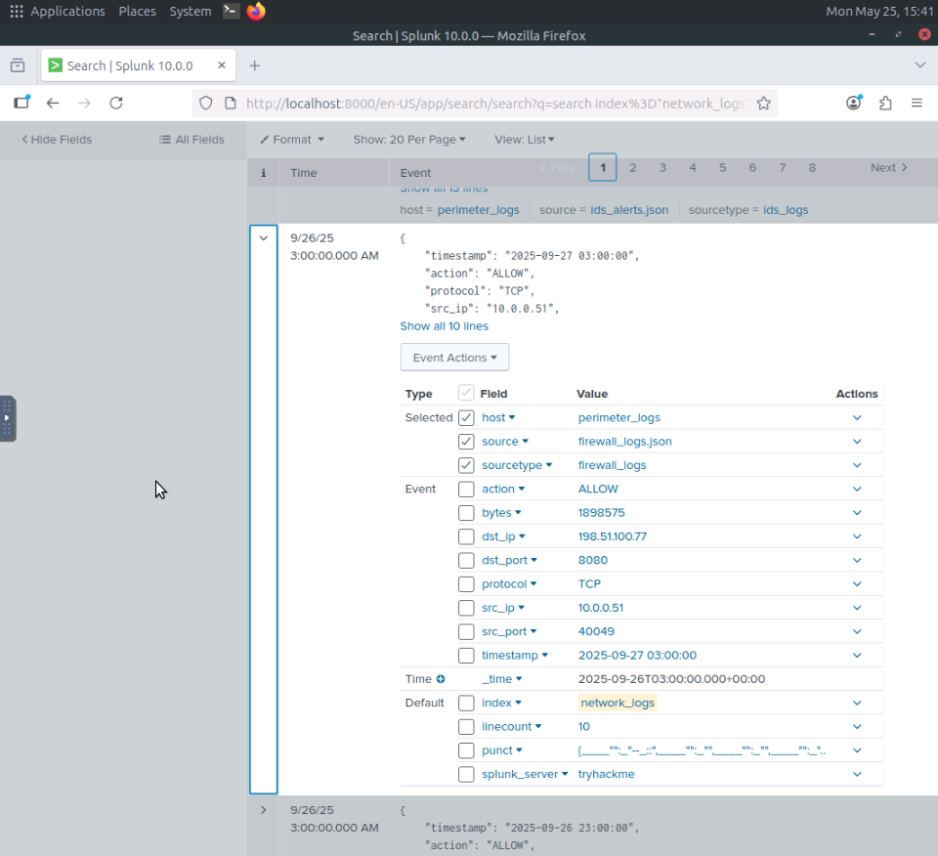
Figure 40: Splunk — expanded firewall log event showing full field structure

6.4 Data Exfiltration Alerts in Splunk
- Splunk IDS alert analysis identified multiple ET INFO Possible HTTP POST Large Upload events classified as Potential Data Exfiltration with Priority 2.
- These events were concentrated on 2025-09-26 and correlated with the C2 beaconing activity observed in the IDS logs, suggesting the compromised host at 10.0.0.60 was actively exfiltrating data.

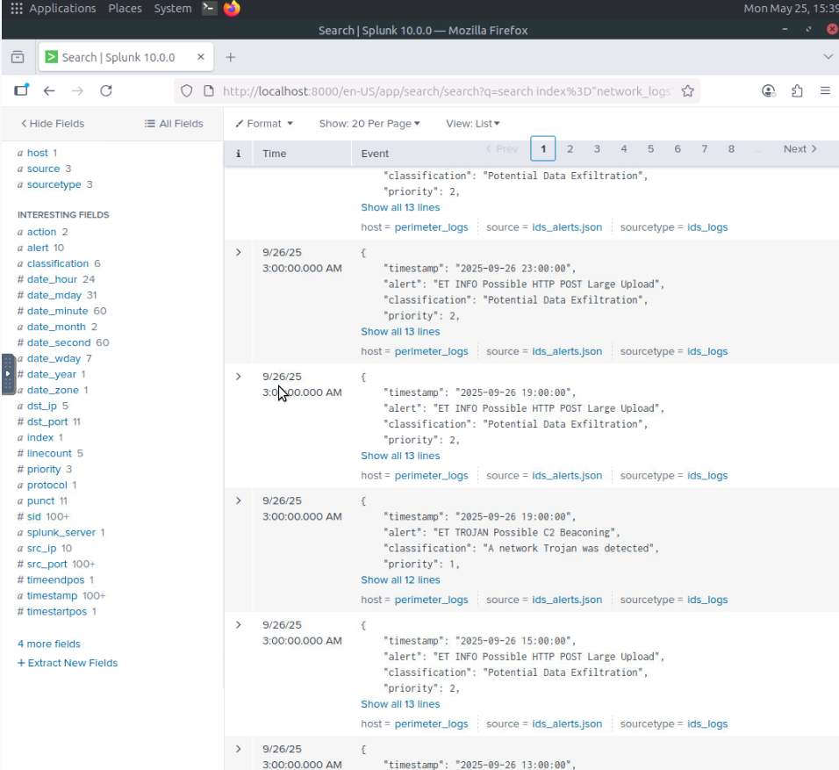
Figure 35: Splunk — data exfiltration alerts and C2 beaconing events correlated in SIEM

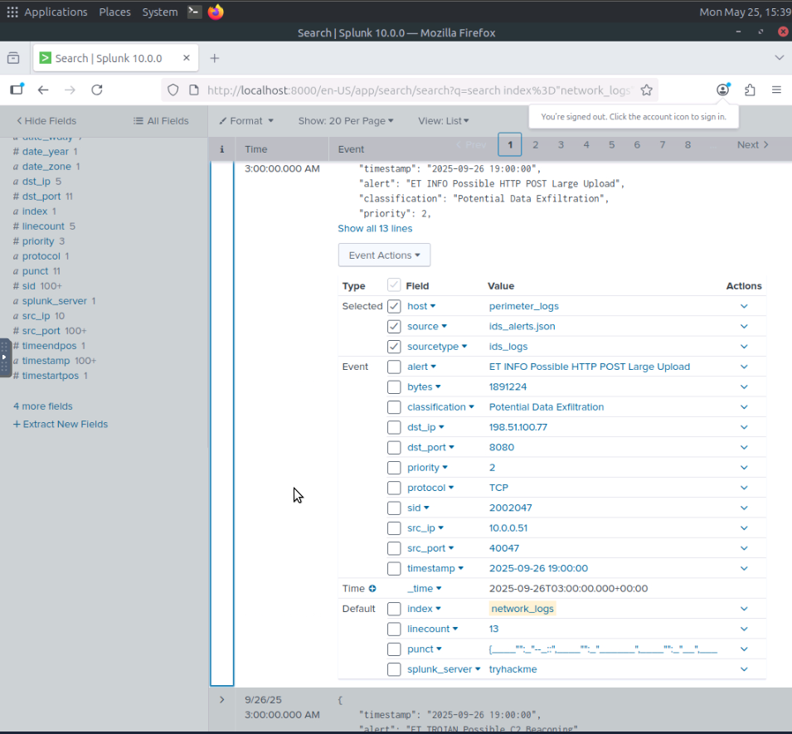
Figure 36: Splunk — IDS alert timeline showing attack progression

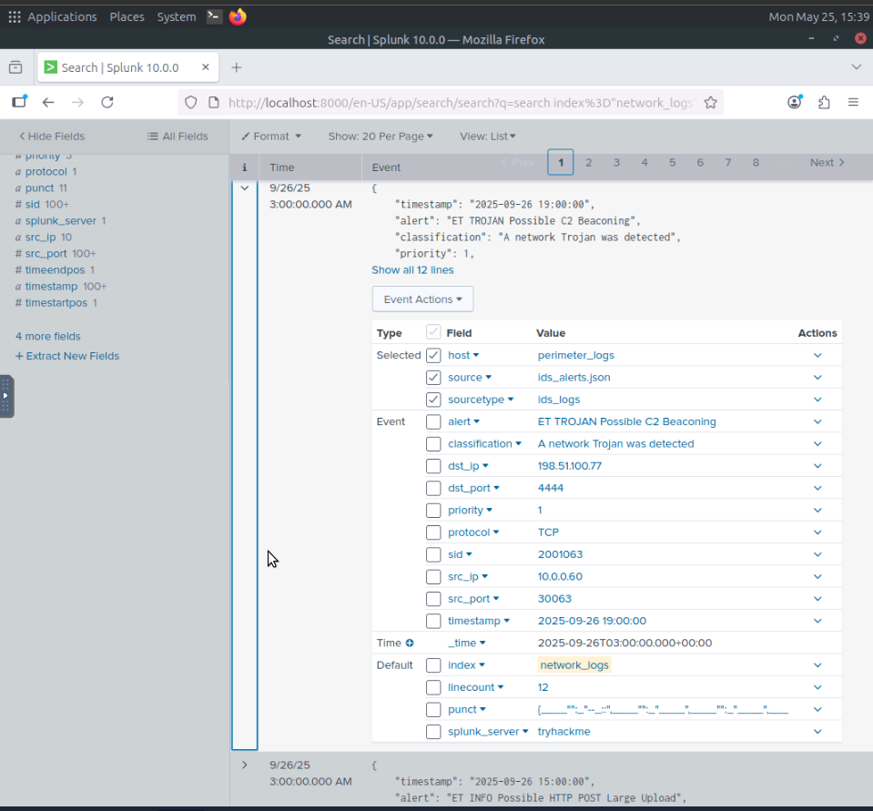
Figure 37: Splunk — additional SIEM correlation results

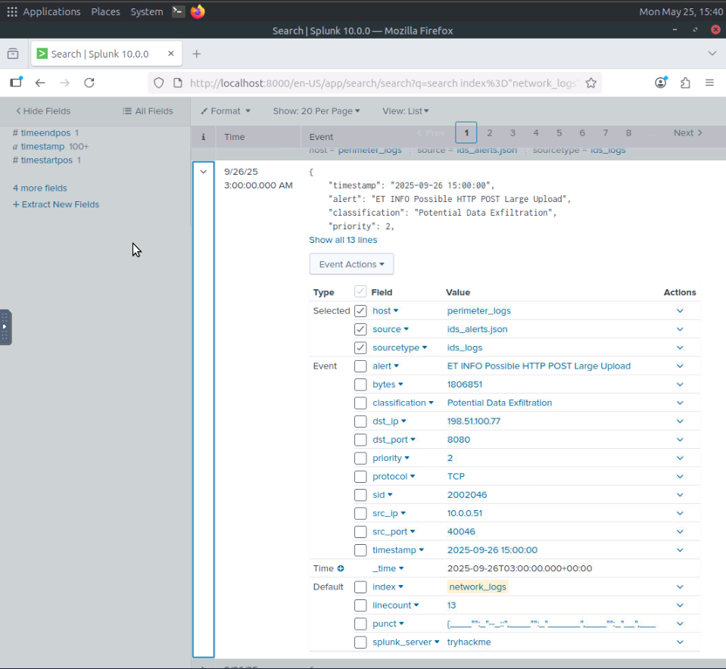
Figure 38: Splunk — Splunk search results showing alert classifications

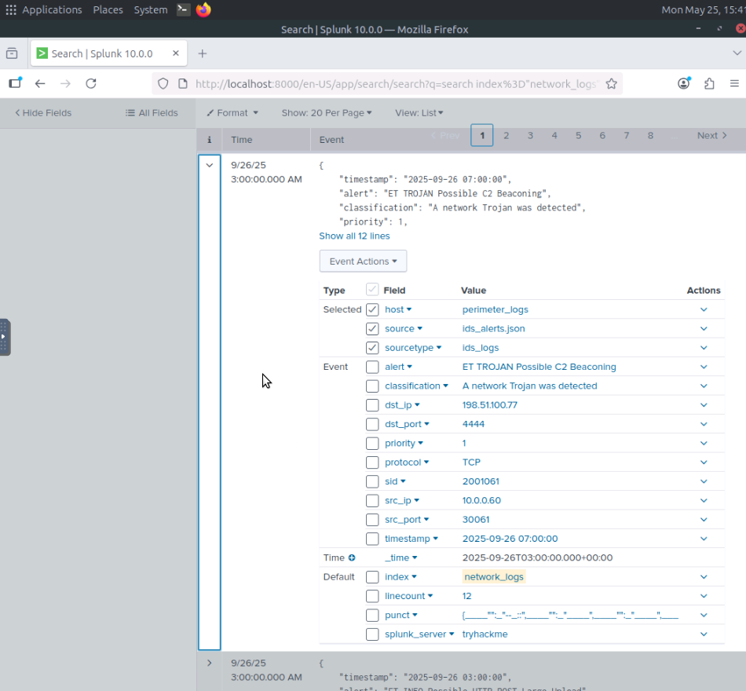
Figure 39: Splunk — final SIEM query results

7. Lab Completion
- The TryHackMe Network Security Essentials room was completed in full.
- All 8 tasks were completed, earning 96 points.


Figure 30: TryHackMe — Room completed: 8 tasks, 96 points, user sawant052

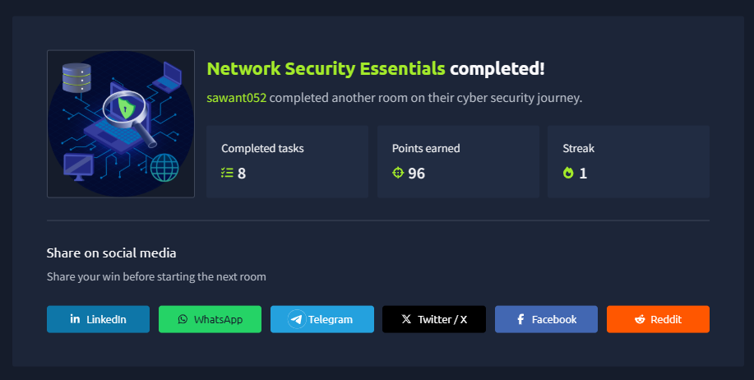
Figure 31: TryHackMe — Network Security Essentials completion certificate

8. Summary of Findings
- The following attack types were identified and analysed during the lab:
- SQL injection
  - WAF rule 942100 blocked UNION SELECT attack from 198.51.100.12 targeting /products.php
- XSS
  - WAF rule 941100 blocked script injection from 198.51.100.12 targeting /search.php
- Directory traversal
  - WAF rule 930120 blocked path traversal attempt to /etc/passwd
- VPN brute-force
  - 45.137.22.13 performed credential stuffing against VPN gateway using 30+ usernames
- Internal port scan
  - host 10.8.0.23 generated high-frequency traffic across ports 22, 445, 3389, 8080
- C2 beaconing
  - host 10.0.0.60 communicated to 198.51.100.7:4444 at 6-hour intervals
- Data exfiltration
  - large HTTP POST uploads from compromised host correlated with C2 activity in Splunk
- MS-SMB lateral movement
  - 32 ET EXPLOIT alerts indicating attempted propagation across internal network
- These findings directly validate the perimeter security controls documented in the Perimeter Security Configuration Guide, confirming that NGFW, WAF, VPN gateway, and IDPS controls generate actionable, correlatable log data that enables effective threat detection and investigation.

